Write an assembly language program to perform division of 8-bit data.  
  
**CODE**

.model small

.stack 100h

.data

dividend db 0C9h

divisor db 20h

quotient db ?

remainder db ?

msg1 db 'The output for the Quotient: $'

msg2 db 0Dh, 0Ah, 'The output for the Remainder: $'

.code

main proc

mov ax, @data

mov ds, ax

mov al, dividend

mov bl, divisor

xor ah, ah

div bl

mov quotient, al

mov remainder, ah

mov ah, 09h

lea dx, msg1

int 21h

mov al, quotient

call display_number

mov ah, 09h

lea dx, msg2

int 21h

mov al, remainder

call display_number

mov ah, 4ch

int 21h

main endp

display_number proc

cmp al, 10

jb single_digit

mov ah, 0

mov bl, 0Ah

div bl

add al, 30h

mov dl, al

mov ah, 02h

int 21h

mov al, ah

add al, 30h

mov dl, al

mov ah, 02h

int 21h

ret

single_digit:

add al, 30h

mov dl, al

mov ah, 02h

int 21h

ret

display_number endp

end main

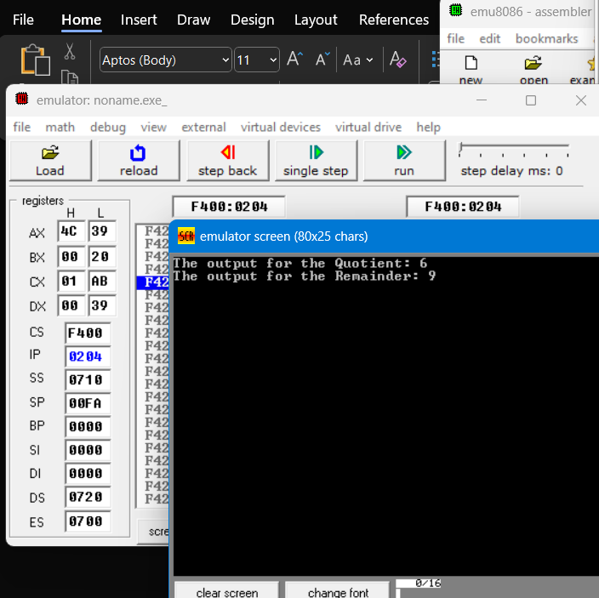

2. Write a program in assembly language to perform division of 16-bit data.  
  
**CODE**  
.model small

.stack 100h

.data

dividend dw 1020h

divisor dw 0022h

quotient dw ?

remainder dw ?

msg1 db 'Quotient: $'

msg2 db 0Dh, 0Ah, 'Remainder: $'

.code

main proc

mov ax, @data

mov ds, ax

mov ax, dividend

mov bx, divisor

xor cx, cx

xor dx, dx

division_loop:

cmp ax, bx

jb division_done

sub ax, bx

inc cx

jmp division_loop

division_done:

mov quotient, cx

mov remainder, ax

mov ah, 09h

lea dx, msg1

int 21h

mov ax, quotient

call display_number_16

mov ah, 09h

lea dx, msg2

int 21h

mov ax, remainder

call display_number_16

mov ah, 4ch

int 21h

main endp

display_number_16 proc

push ax

push bx

push dx

mov bx, 10

xor cx, cx

convert_loop:

xor dx, dx

div bx

push dx

inc cx

test ax, ax

jnz convert_loop

print_digits:

pop dx

add dl, '0'

mov ah, 02h

int 21h

loop print_digits

pop dx

pop bx

pop ax

ret

display_number_16 endp

end main  
  
